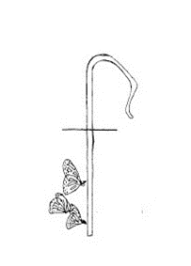 St. Joseph Faith Formation Program
2025-2026 Calendar

September 21: Catechetical Sunday – Classes Begin
October 12 (Sunday): No Classes
November 11 (Tuesday): Veterans’ Day – No Classes
November 25-December 1: Thanksgiving Weekend – No Classes
December 2 (Tuesday): Classes Resume
December 23-January 3: Christmas Break – No Classes
January 4 (Sunday): Classes Resume
February 15 (Sunday): Presidents’ Day Weekend – No Classes
February 17 (Tuesday): Lunar Holiday – No Classes
March 25-April 6: Holy Week/Easter Monday – No Classes
April 7 (Tuesday): Classes Resume
April 26: Last day for Sunday Classes
April 28: Last day for Tuesday Classes

We welcome you to join us on the First Sunday of every Month
for the Children’s Mass at 9:30 in the church,
followed by the Sunday Social in the Hall.

